Adding breadboard friendly terminals to the load cells cables:

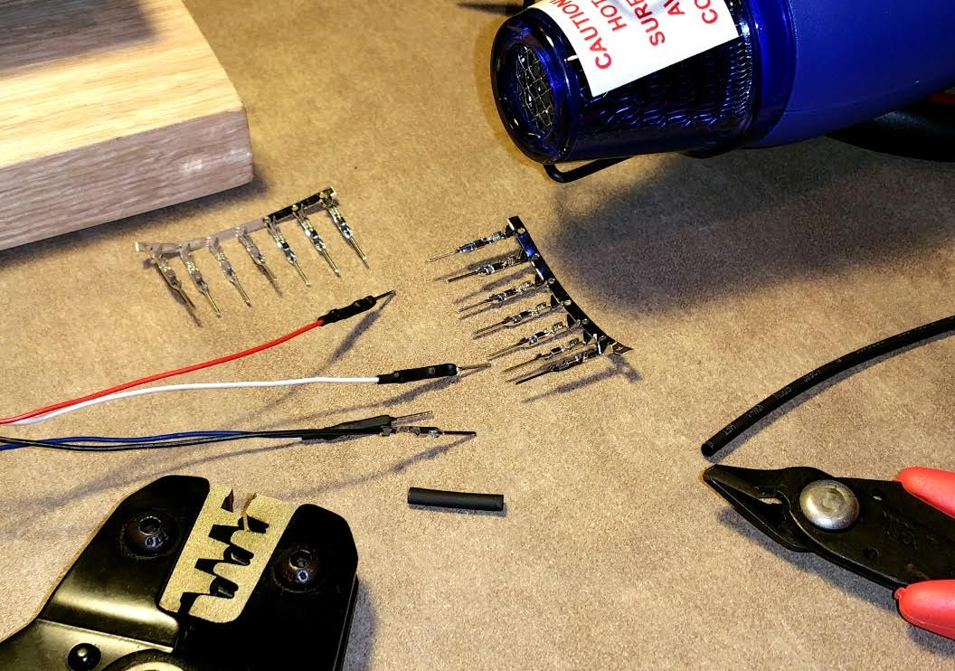

This assembly is not good for multiple weight measurement points (two points are used in this project).

Any misalignment produces forces in the load cells faking the weight measurement...

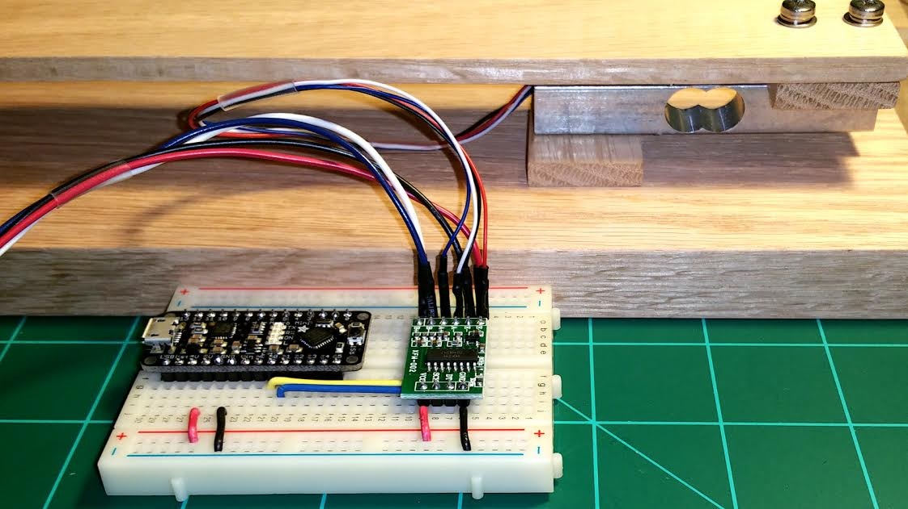



We need pivot points:

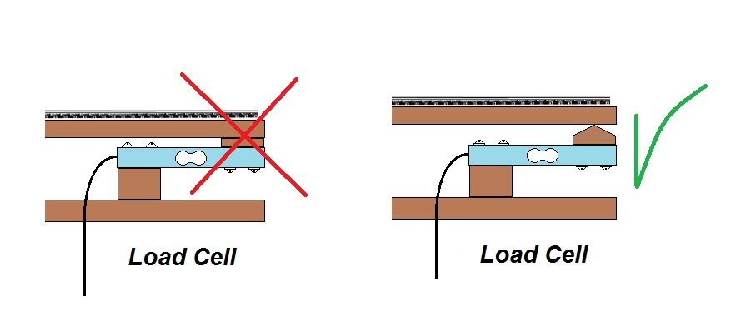

​Soon more news about the "Train Location on the Bridge" project.

Back to the woodworking stage.

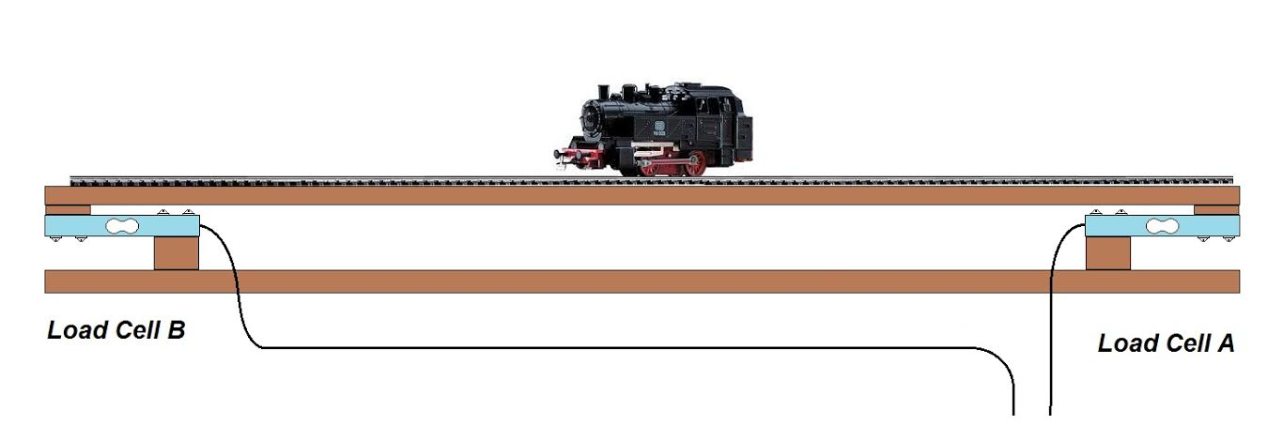

​The Hx711 library only use one channel of the IC.

I will making some changes to the library to use both channels...

